Population pharmacokinetics of cefazolin in maternal and umbilical cord sera and target attainment in term neonates
Omar Elkayal¹, MSc; Karel Allegaert ^{2,3}, MD, PhD; Isabel Spriet^{1,2}, PharmD, PhD; Anne Smits^{1,2}, MD, PhD; Seghaye Marie-Christine⁴, MD, PhD; Corinne Charlier⁴, MD, PhD; Erwin Dreesen^{1,5}, PharmD, PhD
¹ KU Leuven, Belgium, ² University Hospitals Leuven, Belgium, ³ Erasmus MC, Rotterdam, ⁴ Centre Hospitalier Universitaire de Liège – CHU, Belgium, ⁵ Uppsala University, Sweden.
Corresponding authors: omar.elkayal@kuleuven.be, erwin.dreesen@kuleuven.be
Background: Intrapartum administration of cefazolin, a first-generation cephalosporin, is used to prevent vertical transmission of Group B Streptococcus (GBS) in mothers allergic to penicillin without a history of anaphylaxis. Early onset sepsis in the new-born following transmission of GBS during labor or birth may be prevented when exposure to unbound cefazolin in the neonate serum exceeds 1 mg/L (worst-case clinical breakpoint). To date, no information is available on the predelivery maternal cefazolin dose-exposure relationship and subsequent post-delivery duration of neonatal target attainment.
Objectives: The objectives of our work were (i) to build a population pharmacokinetic (popPK) model of cefazolin based on maternal and umbilical cord serum concentrations obtained from women undergoing vaginal delivery and (ii) to investigate duration of prophylaxis target attainment (time above 1 mg/L) in the neonates.
Methods: Data were obtained from 24 healthy pregnant women, between 20 and 41 years old. All women were colonized by GBS and gave vaginal delivery. The minimum gestational age was 32 weeks. Before delivery, the women received a 2 g cefazolin intravenous infusion over 30 minutes. If no delivery occurred eight hours after infusion, a second 1 g cefazolin infusion was given over 15 minutes (8/24 cases). Maternal serum concentrations were obtained according to a fixed sampling scheme with 10 samples per dosing interval (until delivery), plus an additional sample right after delivery. Next to maternal serum samples, arterial and venous umbilical cord blood samples were collected in 12/24 cases, at delivery. Cefazolin concentrations were determined using high-pressure liquid chromatography. A maternal popPK model of cefazolin was built. Subsequent neonatal exposure was predicted using Monte Carlo simulations (n=1000) with the arterial umbilical cord concentration at delivery – predicted from the maternal model – and the neonatal cefazolin model of De Cock et al. (assuming elimination only).¹ Albumin and body weight were sampled from a uniform distribution within the data range reported by De Cock et al. All modeling and simulation were performed using NONMEM 7.4.
Results: The popPK of cefazolin in pregnant mothers was adequately described by a two-compartment model with first-order elimination. None of the tested covariates (body weight and gestational age) were retained in a stepwise covariate analysis (α_{forward}=0.010, α_{backward}=0.001). Subsequently, two additional compartments were added to resemble the arterial (neonatal) and venous umbilical cord (Figure 1; left). Simulations showed 90% attainment of the 1 mg/L target in the neonate for a mean duration of 9.5 hours (Figure 1; right).
Conclusion: The developed maternal popPK model in combination with the neonatal model developed by De Cock et al. showed that traditional predelivery maternal cefazolin dosing provides neonatal antimicrobial protection against GBS for a mean duration of nine hours post-delivery.
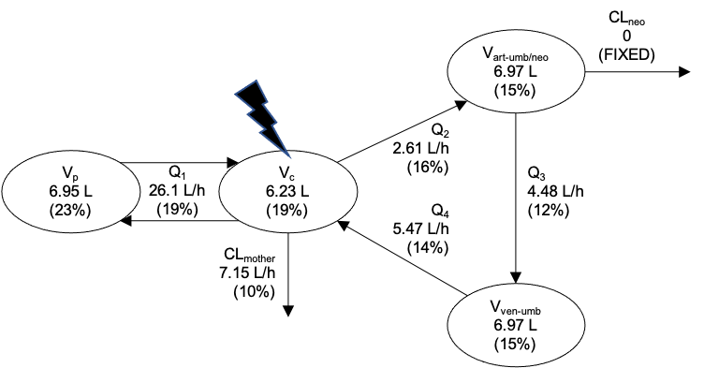
Figure 1. (left) Schematic representation of the predelivery maternal-umbilical popPK model. art: arterial; CL: clearance; neo: neonatal; Q: intercompartmental clearance; umb: umbilical cord; V: volume of distribution; ven: venous. Parameters values are typical values (root squared error). (right) Time since birth vs probability of target attainment (PTA) of the 1 mg/L target for unbound cefazolin. The horizontal line indicates 90% PTA (n=1000). The vertical line indicates the 9.5 hours population mean. The solid black line represents the population mean trend.
References: (1) De Cock et al. J Antimicrob Chemother 2014.

